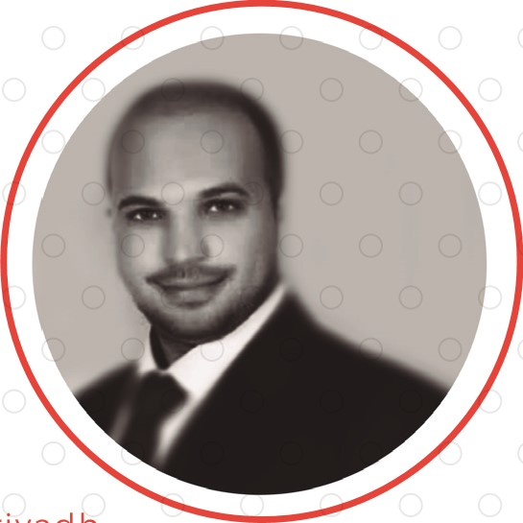KHALED

# AWADALLA

Marketing Operation Manager

+966 56 39 77 5 77 k awadalla@hotmail.com 28 Aug. 1 985 Saudi Arabia, ARriyadh

|  |
| --- |
| PROFILE  My skills cover a wide range of fields and areas within marketing  MARKETING CONSULTANT  Executing & Innovating marketing strategies.  These strategies are centered on the business Aims & The services or products offered.  As well helps to create a detailed marketing plan, determine the marketing messages, & identify the appropriate marketing Integration to get the conclusions .  SKILLS   * Excellent research and planning skills. * Proficient in negotiation & communication. * Good documentation and presentation skills. * Leadership. * Languages Arabic (Native) I English (very good). * ccc driving license   RESPONSIBILITIES   * Research on factors affecting consumer behavior & satisfaction.   Design marketing strategies streamlines to a lead to ease of selling procedures.   * Working in Colaborating with other consultants to discuss strategies & techniques needed for elite clients or Providers. * Manage & Leading all internal & External Sales & Marketing issues. * Developing the company reputation. |

## EDUCATION

Al YARMOUK UNIVERSITY

JORDAN 2006

Bachelor of Marketing

## WORK EXPERIENCE

1/1 1/201 1 -Present : Steps Est. in Saudi Arabia Riyadh 11 as marketing Operation manager 11

in 3 Sectors :- Event management  creation & development Mega events such as festivals, conferences, formal parties, concerts

* Advertising (how to reaching the Announcments for consumers While they in Field

 Marketing consultant (developing a marketing plan & strategies

/6/201 1 -1/9/201 al aamal co. in Saudi Arabia Riyadh Training and Development (trainer ) .( Part time )

trained a new employees in some courses

 Problem solving & decision-making,  Planning and communication skills

2009-201 1 : Hadatheh co. in Jordan" (Irbid Mall- FMCC dept5., Fashion dept., Accessories dept, Restaurant dept.) as Assistant Marketing manager.

 Leading a the marketers & designers

 Preparing advertising & promotion ideas, that helps to increase the salling profit,

 Presenting suggestions that helps to achieve company Obhectives,

 Promotions - Assistant in the planning, budgeting, implementation & evaluate the brands

|  |  |  |
| --- | --- | --- |
| * Collection of promotion data from Market Managers/ distributors & assist in promotion evaluation results, * Help with sourcing & purchasing, Supporting the yearly media |  |  |
| plan, Coordinating the brand's corporate event and |  | MARKETINC |
| sponsorships, Assist with processing of Marketing Expense reports. |  | OPERATION |

MANAGER

2008-2009 : Hadatheh co. Hadatheh co. "in Jordan" as an employee at Marketing dept 

Click the Icon for the Linkedin profile